

Coaching Education Minimum Standards

All member organizations (clubs and academies) that offer youth soccer programing in a Canada Soccer Member Association Province and Territory will be required to meet the minimum Standards of Quality Soccer to be recognized as Quality Soccer Provider within the Canada Soccer Youth Club Licensing Program and in support of the guiding principles of the Safe Sport Roster. Within the Standards for Quality Soccer, it is required that coaches are trained and/or certified appropriately for the program(s) in which they coach and aligned to the Canada Soccer Safe Sport Roster. The minimum standards are further defined below.

Community
Definition:
- All U11 and below teams who do not leave the district for games or tournaments.
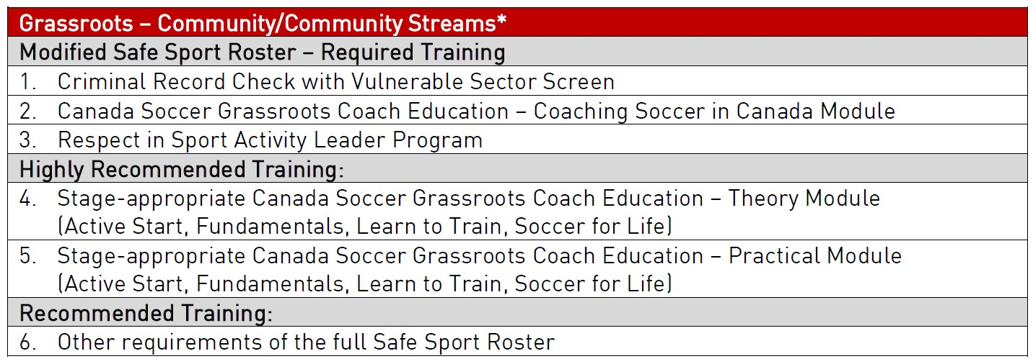

Notes:
- Coaches and Assistant Coaches to be certified to the Modified Safe Sport Roster standards, listed above.
  - Coaching Soccer in Canada Module can only be obtained by purchasing a Stage Appropriate Theory Module as it is not available on its own.
  - Coaches would be encouraged to take the NCCP Rule of Two Module.

- Team Managers will be required to obtain Criminal Record Check with Vulnerable Sector Screen and Respect in Sport Activity Leader Program.
  - Managers would be encouraged to take the NCCP Emergency Action Plan Module and NCCP Rule of Two Module.

- Bench Parents will be required to obtain Criminal Record Check with Vulnerable Sector Screen.

Competitive
Definition:
- All U13 and above teams.
- All U11 and below teams who leave the district for games or tournaments.
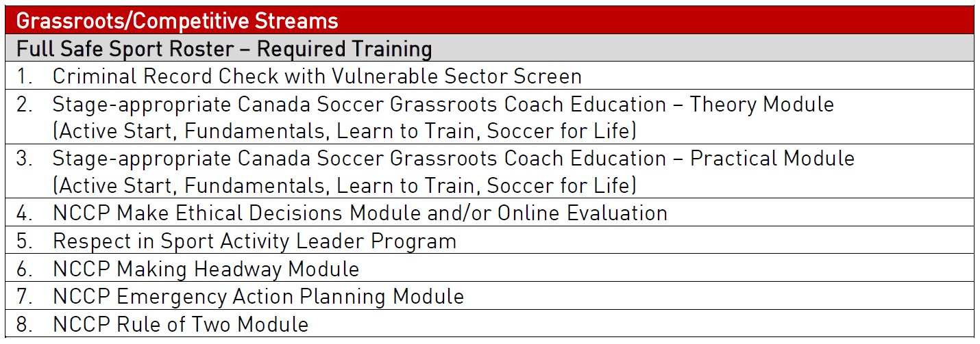
Notes:
- Coaches and Assistant Coaches to be certified to the Full Safe Sport Roster standards, listed above.

- Team Managers will be required to obtain Criminal Record Check with Vulnerable Sector Screen and Respect in Sport Activity Leader Program.
o Managers would be encouraged to take the NCCP Emergency Action Plan Module and NCCP Rule of Two Module.

Where to Find Courses:

Respect in Sport for Activity Leaders: https://albertasoccer.respectgroupinc.com/koala_final/
NCCP Courses: https://thelocker.coach.ca/account/login
- Register to obtain an NCCP Number
- NCCP Rule of Two Module
- NCCP Emergency Action Plan Module
- NCCP Making Headway Module
- NCCP Make Ethical Decisions Module and/or Online Evaluation
Canada Soccer Grassroots Coach Training (each one includes Coaching Soccer in Canada Module):
https://canada-soccer.myshopify.com/collections/grassroots-coaching-education-program
- Active Start: Designed for coaches of U5 players and consists of completing 1.5 hours of online training followed by a 2-hour Practical On-Field Workshop. No pre-requisites required.
- Fundamentals: Designed for coaches of Boys and Girls U7-U9. It consists of completing 1.5 hours of online training followed by a 3-hour Practical On-Field Workshop.
- Learn to Train: Designed for coaches of Boys and Girls U11. It consists of completing 2 hours of online training followed by a 4-hour Practical On-Field Workshop.
- Soccer for Life: Designed for coaches of Boys and Girls U13+. It consists of completing 2 hours of online training followed by a 4-hour Practical On-Field Workshop.

